# Processing Serial Port routines

## Quick Start Guide

Install processing

<https://processing.org>

Aside installation of Processing IDE (3XX or 4XX) one needs to add G4P and Console libraries to the Processing IDE, accessed by menu item **Sketch>>Import Library>>Manage Libraries** and search for “**G4P**” and “**Console**”, click the library name to select then press install button.

All other dependencies are either default processing libraries, default java libraries or placed in the “code” folder of the application.

Ideally you should only have to edit **launch.pde** or add your own extra **\*.pde**. All class functions and variable of moment can be accessed from **launch**. There are up to three files in the data folder after running the application. **Comms.dat** store’s the comm port parameters, **File1.dat** which will be your received data if you pressed “**File Open**” button (file name used for relevant process in the functions screen “**File to Save**” panel) and **log.txt** which will contain the logger files.

Launch Processing IDE.

* Open the project from your hard drive.
* Press run button on the IDE and the application should run.

You will be presented with four buttons.

* **Exit** is logical. Closes all comm ports and exits.
* **Open** launches a new window with selection options for the comm ports. If there are no comm ports listed on this screen it means you have no recognizable comm ports on the system.
* **Send** just send hard coded string data out the selected serial port.
* **File Open** Opens a file to save RX data to, file name is from the functions screen. File gets saved to **data** directory of the project.

If you open a comm port, the port will remain open for the whole time the application is running until you exit from the application, or until you close it via code, or by opening the serial port window and pressing close button.

Minimum code to launch.

***serial_gui new_serial;***

*void setup()*

*{*

*size(500,300);*

***new_serial = new serial_gui(this);***

*}*

*void draw()*

*{*

*}*

But typically, one would launch serial_gui from a button action.

*import g4p_controls.G4P;*

*import g4p_controls.GButton;*

*GButton btn_open;*

***serial_gui new_serial;***

*void setup()*

*{*

*size(500,300);*

*btn_open = new GButton(this, 10, 260, 65, 30);*

*btn_open.setText("Open");*

*btn_open.addEventHandler(this, "btn_open_click");*

*}*

*void draw()*

*{*

*}*

*public void btn_open_click(GButton source, GEvent event)*

*{*

*if(source == btn_open && event == GEvent.CLICKED)*

*{*

***new_serial = new serial_gui(this);***

*}*

*}*

The example project uses the button approach.

## Details of Serial Parameter screen

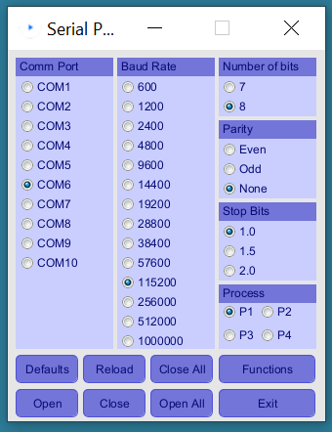

Most of the parameters are logical so won’t go into them.

**Process** panel intent is to allow up to 4 separate comm ports to be under separate software control.

**Buttons**

* **Defaults** Loads hard coded default parameters for all processes as a starting point.
* **Reload** Re-Loads all the process from the hard drive (if you want to get back to what you had at the start before you started modifying things)
* **Close All** Closes all the open ports (Process 1>>4)
* **Open All** Opens all the ports (Process1>>4)
* **Open** Opens the comm port for the specific selected process with parameters as detailed on the screen.
* **Close** the comm port for the specific process selected.
* **Exit** Save the parameters for all processes (including those parameters on the functions screen (whether you opened it or not)) to comms.dat file and leaves any ports open in their open state for use elsewhere in your code.
* **Functions** as below.

## Details of Function Screen

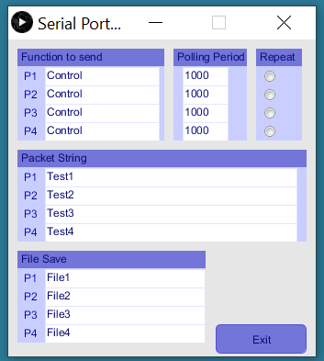

**Function to send** is the actual JAVA/Processing function one uses to send a specific processes command under timing control. Means you can have tailored functions to do specific things.

**Packet String** is the string that actually gets sent ("**Test1>>Test4**"), and it is sent by the **Function to Send**definition (**"Control"**function in this case). Control is the default function for polled events.

**Polling Period**time is milli seconds and Repeat option is the fact that it repeats, aka polling.

**File Save** is used for file name when current process file is opened for “appending”. File class allows other options but only append implemented in launch.pde.

## RX Data Access

To Access received data following is implemented in **launch.pde**

Below function calls the function in the “**serial_ports**.**pde**” class relevant to the opened port.

void serialEvent(Serial p)

{

new_serial.specific_process[associated_process].serialEvent(p);

String inString = new_serial.specific_process[associated_process].strarray_rx[new_serial.specific_process[associated_process].current_rx_pointer];

println("Serial Event :- " + inString + " Port :- " + p);

}

## Comment on RX Data

Current code is setup to wait for a Line Feed “lf” aka “0x10” to fire a Serial port event to receive data.

Based on this

myPort.bufferUntil(byte(10));

If your data stream has some other terminating character you will need to update this. Can be updated in the comms.dat file or programmatically in launch.pde with

new_serial.specific_process[associated_process].setBuffer_char(byte(10));

or something other than 10. Eg 13 might be valid, aka carriage return.

There is another option, that being wait till X number of chars have been received before firing an event, but that is not yet fully implemented.

## Outstanding Issues

There are two issues still to be resolved.

* First is an issue with SLF4J being found in Console and one in JSSC (serial port jar). It doesn’t seem to impact the code other than the warning apparent in 4_0B8. Remove the Console if you’re not happy with this warning.

SLF4J: Class path contains multiple SLF4J bindings.

SLF4J: Found binding in [jar:file:/C:/Users/stefa/OneDrive/Documents/Processing/libraries/Console/library/slf4j-log4j.jar!/org/slf4j/impl/StaticLoggerBinder.class]

SLF4J: Found binding in [jar:file:/C:/Compilers/processing-4.0b8/modes/java/libraries/serial/library/jssc.jar!/org/slf4j/impl/StaticLoggerBinder.class]

SLF4J: See http://www.slf4j.org/codes.html#multiple_bindings for an explanation.

SLF4J: Actual binding is of type [org.slf4j.impl.Log4jLoggerFactory]

* Second, 4_0B8 uses OpenJDK as opposed to 3_5_3 uses Oracle JDK. The Gui is larger when using OpenJDK and the graphics for G4P doesn’t look as good. Seems to have no impact on the code function. If I find a solution I will update the code.

## To Be Done